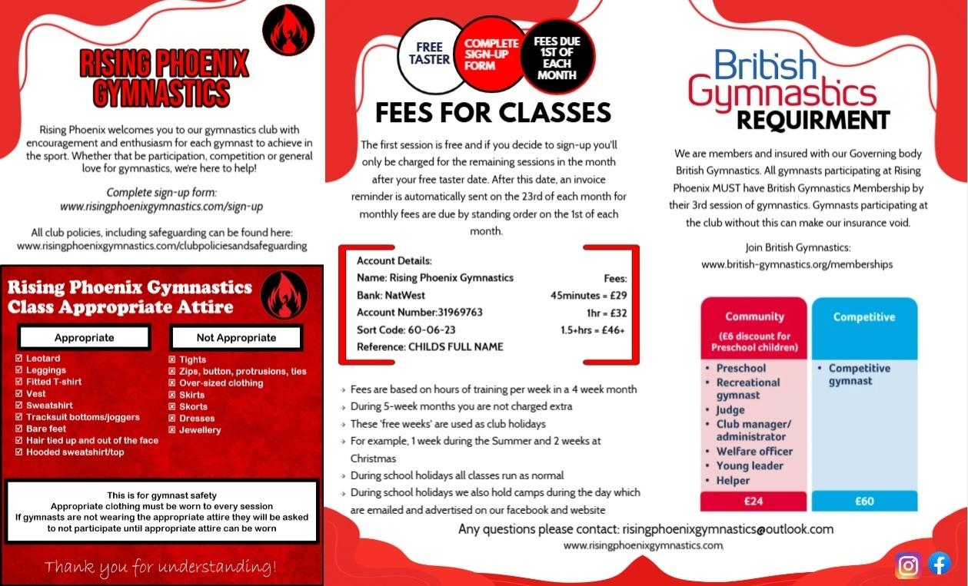

| **Code of Conduct for Participants**  Rising Phoenix Gymnastics Club (RPG) we’re here to make your gymnastics sessions as fun and safe as possible. We need **YOUR HELP** to make sure everyone has a positive gymnastics experience.  What can I do in the session to help keep it fun and safe? | | | | | |
| --- | --- | --- | --- | --- | --- |
|  | * Listen to all instructors |  | * No food in the gym |  | * Use an look after the equipment as instructed |
|  | * Ask if I need help |  | * Try your best and give it your all in every session! |  | * Respect and Celebrate difference in the club - do not discriminate against anyone else |
|  | * Be kind, friendly and supportive - encourage others and be patient with other gymnasts |  | * Be dressed and ready to participate |  | * Always tell the instructor if I feel sick or have got an injury |
|  | * Participate in all sections of the class |  | * I have my water bottle and it's filled |  | * Online and social media - think before you post or contact anyone online to do with Rising Phoenix |

| What I should avoid during gymnastics | | | |
| --- | --- | --- | --- |
|  | * Enter the gymnastics area unless a coach/instructor or staff member permits you to do so |  | * Use bad language or yell/abuse anyone. |
|  | * Bully anyone or pressure other gymnasts to do something they don’t want to do |  | * Take part in inappropriate or illegal behaviour. |
|  | * Use a mobile phone during training, at competition or in changing rooms |  | * Carry or consume alcohol or illegal substances while training or competing in gymnastics. |
|  | * Use mobile phones or other electronic devices to undermine, put down or belittle other gymnasts, coaches/instructors or staff members. |  |  |
|  | * Carry or consume alcohol or illegal substances while training or competing in gymnastics. |  |  |

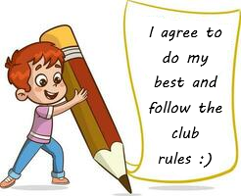

**Gymnasts Name: ___________________________________________________________________________**

**Signature of Gymnast: ____________________________ Date: _____________________**  
  


**Parent/carer Signature (if under 18): _________________________________________**



**Rising Phoenix Gymnastics Code of Conduct for Guardians**

Rising Phoenix Gymnastics Club (RPG) believes in the importance of an encouraging, enjoyable and professional workplace. This Code of Conduct is to protect the Club, Staff, Volunteers and all its members.

| **CONTACTS** | |
| --- | --- |
| Club Email | risingphoenixgymnastics@outlook.com |
| Welfare Officers | risingphoenixwelfare@outlook.com |

All Guardians of our members are asked to:

* Encourage your child to learn and follow the rules of the club
* Discourage challenging/arguing with Staff, Volunteers, Officials and other members in the club.
* Encourage your child to recognise good performance, not just results.
* Set a good example of Sportsmanship and applauding good performance of all members.
* Encourage your child’s participation in sport without force.
* Ensure your child is appropriately dressed and ready for participation including a drink.
* Keep the club informed if your child is ill or unable to attend any sessions.
* Keep the club informed of any changes to yours or your child’s details and medical information.
* Ensure all fees for training/competitions are paid the correct amount and by the correct date (1st of each month).
* Accept the Staff/Volunteers/Officials decisions and/or request a discussion in an appropriate manner by contacting [risingphoenixgymnastics@outlook.com](mailto:risingphoenixgymnastics@outlook.com) to book a face-to-face meeting.
  + Participation in meetings
    - Staff/Volunteers: meetings may involve more than one staff/volunteer member and/or Welfare Officer depending on what the meeting is regarding.
    - Guardians: You are more than welcome to bring another adult to any meeting for support if you feel it is needed.
    - Appointments can be arranged by contacting the club outside of session times at an agreed time by both parties.
* Ensure good communication is kept between yourself and RPG.
* Express Grievances and Complaints following RPG’s procedure – contacting our Welfare Officer Lauren Parker: lauren.parker85@hotmail.co.uk
* Please do not post unfavourable, personal, or disrespectful comments regarding gymnasts, coaches, club personnel, the club or any other club on any public social media networks.
* Please use correct and proper language at all times – no swearing or derogatory terms.
* Never punish or belittle a child for poor performance or making mistakes.
* Always collect your child promptly at the end of each session.
* Should you wish to use the viewing area, do not cause any distraction to any gymnast or coach from the viewing area.
  + Should you need to communicate with your child please speak to the coaches at an appropriate time.
  + In case of an emergency please gain the attention of the staff in a safe and considerate way.
* Support your child’s involvement and help them to enjoy their sport
* When attending events please adhere to the photography rules and regulations set out by the organisers.
* Share any concerns or complaints about any aspect of the club through the approved channels (see compliments/complaints procedure)
  + ‘Gym Hopping’ can be described as contacting another club to seek advice or a trial for your child whilst they are still part of RPG. We ask if any concerns with the club are raised before contacting any other club.
* Common Courtesy Clause – if attending the club for a trial with your child from another club we hold the right to inform their original club out of common courtesy for other clubs.

**Any breach to this code of conduct will be dealt with in accordance with our disciplinary procedure.**

**Guardians/Visitors/Spectators Signature:**

**Date:**

| **ALL CLUB POLICIES CAN BE FOUND HERE:** [**https://www.risingphoenixgymnastics.com/clubpoliciesandsafeguarding**](https://www.risingphoenixgymnastics.com/clubpoliciesandsafeguarding) |
| --- |

Rising Phoenix Gymnastics Sign-up form

Online version of this form available here: <https://www.risingphoenixgymnastics.com/sign-up>

| **Class Time** | **Training Day** |
| --- | --- |
|  |  |
| **Gymnasts First Name** | **Gymnasts Last Name** |
|  |  |
| **Date of Birth** | **Gender** |
|  |  |
| **Email:** | |
| **Full Address:** | |
| **Emergency Contact 1** | |
| **Full Name** | **Relationship to Gymnast** |
|  |  |
| **Contact Number:** | |
| **Emergency Contact 2** | |
| **Full Name** | **Relationship to Gymnast** |
|  |  |
| **Contact Number:** | |
| **Medical Information: Anything we need to know or can help with?** | |
|  | |

| **Please sign your name to the below for agreements.** | | |
| --- | --- | --- |
| YES/NO | I agree for the participant to receive First Aid by a qualified first aider | |
| YES/NO | I give permission for PHOTOS/VIDEOS of my child to be used for PUBLIC social media and Website for the use of celebration and promotion of the club | |
| Sign: | I have found the clubs policies and safeguarding on the clubs website | |
| Sign: | I have signed the Code of Conducts for Guardians | |
| Sign: | I confirm my child as signed the Code of Conduct for Participants | |
| Sign: | I give permission for my child to participate in classes at Rising Phoenix Gymnastics | |